Appendix 7.1

Chemistry Specifications for Chemistry Services Contractors
National Toxicology Program
Examples of HTS Plate Maps and Structure Files
September 12, 2013

- Plate Map
  - A partial plate map is shown in Figure 1.
Figure 1.
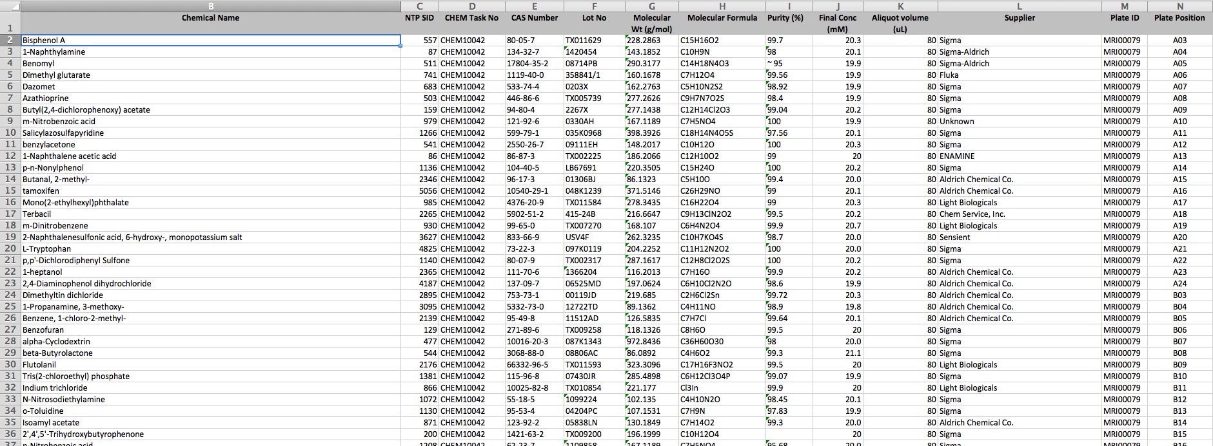
  - Field names (column titles) and definitions are listed below:
    - Chemical Name
    - NTP substance identification number (SID)
    - CHEM Task No: Number assigned to the handling assignment by the NTP IMS.
    - CAS Number
    - Lot number
    - Molecular Wt (g/mol): Molecular weight of the chemical used to calculate the molarity of the dispensed solution.
    - Molecular formula
    - Purity (%): Supplier or as determined, if available.
    - Final Conc (mM): Prepared concentration of the solution in the well.
    - Aliquot volume (uL): Volume dispensed into the well
    - Supplier
    - Plate ID
    - Plate Position: Row and column identifiers
- Structure File
  - A partial structure file in Excel format is shown in Figure 2.
Figure 2.
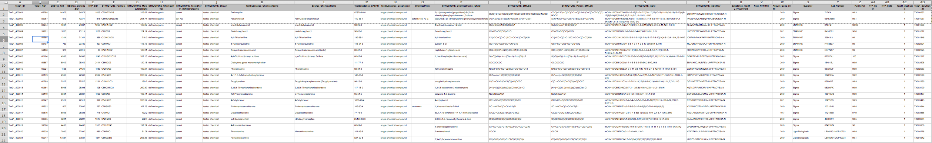
  - Field names (column titles) are listed below:
    - Tox21_ID
    - Tox21_RID
    - DSSTox_CID
    - DSSTox_Generic_SID
    - NTP_SID
    - STRUCTURE_Formula
    - STRUCTURE_MolecularWeight
    - STRUCTURE__ChemicalType
    - STRUCTURE_TestedForm_DefinedOrganic
    - STRUCTURE_Shown
    - TestSubstance_ChemcialName
    - Source_ChemicalName
    - TestSubstance_CASRN
    - TestSubstance_Description
    - ChemicalNote
    - STRUCTURE_ChemicalName_IUPAC
    - STRUCTURE_SMILES
    - STRUCTURE_Parent_SMILES
    - STRUCTURE_InChi
    - STRUCTURE_InChiKey
    - Substance_modify_yyymmdd
    - Note_NTPHTS
    - Aliquot_Conc_(mM)
    - Supplier
    - Lot_Number
    - Purity (%)
    - NTP_Set1
    - NTP_SetB
    - Tox21_duplicate
    - Tox21_Solution_ID
  - Definitions for fields and example structure files can be found on the DSSTox website at: http://www.epa.gov/ncct/dsstox.

